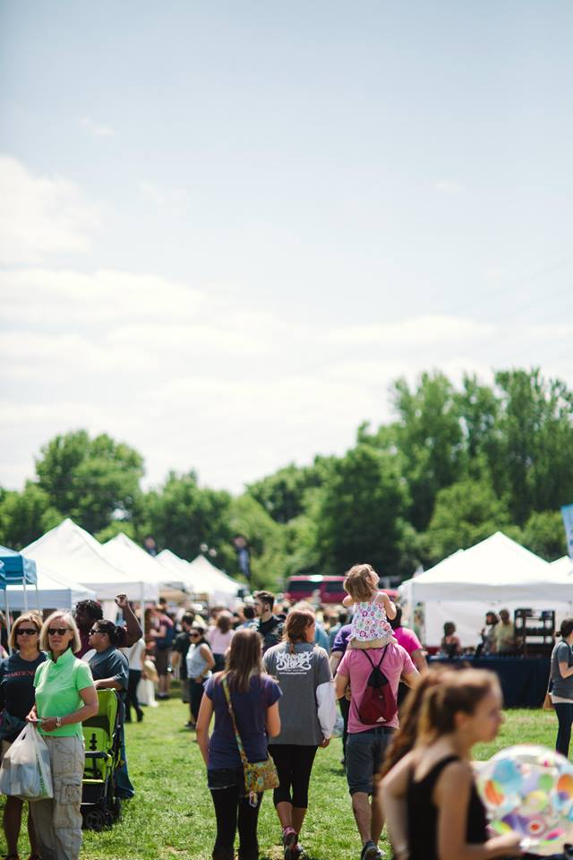
February 2016

The Louisville Independent Business Alliance is preparing a community celebration of local and independent businesses at our 8th annual Buy Local Fair on May 22, 2016. I’m writing to invite you to be part of this meaningful and popular event.

This event has continued to amaze us with the level of support from the community. Over 8,000 people attended in 2015 and we are expecting even more in 2016. Attendees come not only for excellent shopping, eating and a good time, but also to show their resounding support for the local independent businesses that make their community unique.

The Louisville Independent Business Alliance is a non-profit organization dedicated to preserving the unique community character of the Metro Louisville area by promoting locally-owned businesses and educating citizens on the value of buying locally. We are also known by our “keep Louisville weird” campaign, designed to instill pride in Kentuckians for our local merchants and producers who are unique to our hometown.

Money raised from the event will support LIBA’s programs and education efforts throughout the year, including such efforts as the distribution of 80,000 Buy Local Guides, materials for our member businesses, community outreach that educates the public about the benefits of buying locally, support for our member businesses, etc. For more information about our efforts, visit www.keeplouisvilleweird.com.

Sponsorship of the Buy Local Fair is an excellent marketing opportunity, and a way to show your pride in your community. I think you will be pleased with the various benefits provided to recognize your brand. Keep in mind that these sponsorship levels are not absolute. You may have other benefits you’d like to suggest or budgets in mind, and we are happy to customize a package that is mutually beneficial.

Thank you for taking the time to examine these opportunities. I look forward to hearing from you.

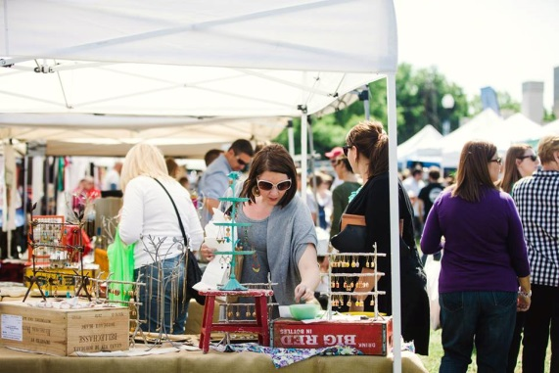
Best regards,

Jennifer Rubenstein
Director
Louisville Independent Business Alliance
1974-A Douglass Blvd., Suite 101, Louisville, KY 40205
502-473-4687
Cell: 502-500-4669
jennifer@kepplouisvilleweird.com
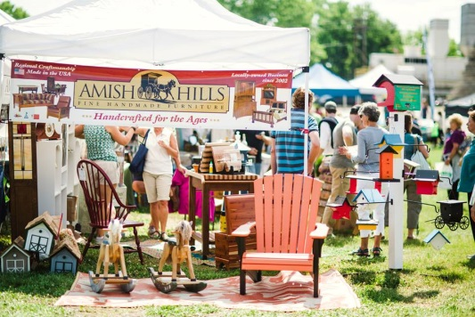
Partner with LIBA to bring Louisville’s most successful Buy Local gathering
to over 8,000 attendees.
Sponsorship Highlights

Louisville Independent Business Alliance [LIBA] invites you to partner with them in the development of the city’s most successful Buy Local celebration. This one-day, 6 hour, festival is the largest Buy Local event of the year, taking place at the Louisville Water Tower Park property. Fair admission is free and open to everyone, with parking at $5 per vehicle. (Bicycle parking is free.)
Louisville’s Buy Local Fair Elements
More than 8,000 people are expected to attend this day of family fun and recreation. Live music and entertainment will be featured including a local arts and craft market, Iron Chef-style competition featuring all locally sourced food, craft beer tent, the Back Porch (relaxation area by the river for the grown ups) and H2O Kids Zone. The Fair hosts over 180 vendors showcasing goods, consumables and services.

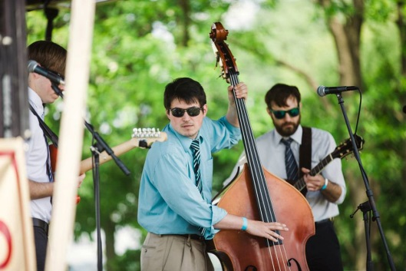
Promotional Campaign
Sponsors will benefit from a local marketing campaign comprised of local media outlets including TV, radio, print, electronic [social media, blogs and websites] and outdoor media. Sponsors also have an opportunity to benefit from advertising in LIBA Business Member retail outlets [over 500], via an event poster. The Media rollout will begin in March 2016 for the Buy Local Fair.
Demographic Exposure
The Buy Local Fair appeals to people of all ages and from every part of the community. Great local food, local crafted goods, quality entertainment and family activities attract visitors from all over Louisville Metro and Southern Indiana. The Buy Local Fair is a single-source way to reach your target demographic of local consumers and those interested in learning of local options for goods and services.
Enduring Popularity
Vendors of all shapes and sizes consider the Buy Local Fair to be a “must do” event. We fill up quickly with businesses of every variety. While the Fair is predominately retailers with items to sell, there are many service providers (from massage to banking to home renovation) that participate. The booths fill up quickly and there is always a waiting list to get in. This alone is a testament to the effectiveness and value of the Fair.

Buy Local Fair 2016 Sponsorship Levels  At-A-Glance | Local Legend ($5,000)  1 available | Community Champion ($2,500)  2 available | Neighbor-hood Notable ($750) | Premium Booth ($200) | Custom Sponsorship (Varies)
Significant naming opportunity for an area within the Fair [Auction, Stage, etc.] | Yes | No | No | No | Have a particular goal/budget in mind? Let Jennifer know and LIBA will customize a package for you.
Name to be included in all Fair promotion with link to company site on all social media/email campaigns/electronic invitations | Large Logo | Logo | Name (logo when space permits) | No
Category Exclusivity for Sponsorships | Yes | Yes | No | No
Sponsor Interview/Spotlight on Website, Facebook and Twitter | Yes | Yes | No | No
Logo on event map/program and highlighted listing | Large logo with highlighted listing | Logo with highlighted listing | Highlighted listing | Bolded listing
Sponsor name and/or logo on  - Advance promotional banner on Louisville Water Tower Park property  - Main stage | Large Logo | Logo | Name (logo when space permits) | No
Opportunity to be included in shared media segments [as opportunities permit] | Yes | Yes | Yes | No
Opportunity to promote a giveaway for Buy Local Fair Packages in advance of the event (each package includes parking voucher, event t-shirt and handmade mug, supplied by LIBA) | 10 | 5 | 0 | 0
Address festival goers from stage | Yes (up to 3x) | Yes | No | No
Emcee acknowledgment throughout event | Yes | Yes | Yes | No
Opportunity to include literature or an item in over 150 vendor welcome packages | Yes | Yes | No | No
10’ x 10’ Premium Location(s) with electricity, ie. on corner, near stage, etc. (Partner is responsible to bring tent, tables, chairs.) | Two Premium (can be tandem or separate) | One Premium | One Premium | One Premium
Opportunity for placement of large onsite banners [Sponsor-provided] | 2 banners | 1 banner | 1 banner | No
One Year of Partner Membership in LIBA (see additional sheet for benefits) | Patron  ($3,500 value) | Key Investor ($1200 value) | Shareholder ($500 value) | No
Merchandising opportunity within Fair Merch Area (in addition to your booth) | Yes | No | No | No
Featured parking onsite for display of promotional vehicle, inflatable or other item | Yes | Yes | No | No
Unlimited parking passes for sponsor booth volunteers and company representative | Yes | Yes | Yes | Yes
Handmade beer steins with drink tickets and Buy Local Fair 2016 T-Shirts | 10 steins/5 t’s | 5 steins/3 t’s | 3 steins/  2 t’s | 1 stein
Option to provide item for Buy Local Fair Raffle | Optional | Optional | Optional | Optional

Louisville Independent Business Alliance
8th Annual Buy Local Fair | Sunday, May 22, 2016, 12n-6pm

Sponsor Application Form

Organization Name _________________________________________________________________________________________

Contact Person ____________________________________________________________________________________________

Address __________________________________________________________________________________________________

City _____________________________________________________ State ___________________ Zip __________________

Phone ______________________________ Email _________________________________________________________________
Level of participation:

Local Legend [$5,000] Community Champion [$2,500] Neighborhood Notable [$750]

Premium Booth [$200] Custom Sponsorship (email jennifer@keeplouisvilleweird.com)
Auction Item ______________________________________________________________ Retail Value: $ _______________

Electricity: I will need electricity for my booth I will not need electricity for my booth

Payment Method:

Check [enclosed, payable to LIBA] Please invoice me at the address above

Credit card number: _______________________________________________________________________________
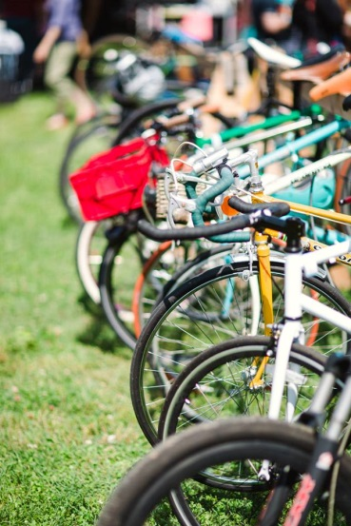
Security Code :_________________ Expiration Date: _____________________
Signature:___________________________________________________________

Please return your application by March 15, 2016 to:
Louisville Independent Business Alliance jennifer@keeplouisvilleweird.com
Attn: Jennifer Rubenstein
Office Phone & Fax: 502-473-4687
Cell: 502-500-4669
1974-A Douglass Blvd., Louisville, KY 40205 www.keeplouisvilleweird.com

